BUG HUNTING PROJECT – Real-World Vulnerability Discovery
Student Name: Osiogbhemhe Oarue-Itseuwa

Introduction
Bug bounty programs allow ethical hackers and security researchers to identify and responsibly disclose vulnerabilities in real-world systems. Platforms like HackerOne, Bugcrowd, Intigriti, and YesWeHack help organizations improve security by rewarding valid findings.

Task 1 – Out-of-Scope Analysis
In bug bounty programs, 'Out of Scope' refers to systems, vulnerabilities, or testing methods that are not authorized for testing.
- Examples of out-of-scope vulnerabilities:
- Self-XSS
- Rate limiting issues
- Missing security headers
- Clickjacking
- Denial of Service testing
Testing outside scope may result in account suspension, legal consequences, platform bans, and reputational damage.

Task 2 – Payout Mapping
Selected Program: HackerOne
Severity Level | Example Vulnerability | Estimated Payout Range
Low | Information Disclosure | $50 – $300
Medium | Cross-Site Scripting (XSS) | $300 – $1,000
High | Insecure Direct Object Reference (IDOR) | $1,000 – $5,000
Critical | Remote Code Execution (RCE) | $5,000+

Task 3 – Dummy Bug Report

Title
Reflected Cross-Site Scripting (XSS) Vulnerability in Search Function

Target
Demo Web Application Program

Vulnerability Type
Reflected Cross-Site Scripting (XSS)

Severity Level
Medium

Description
A reflected XSS vulnerability was identified in the application's search functionality. User input is reflected back into the browser without proper sanitization.

Impact
The vulnerability may allow session theft, phishing attacks, malicious redirects, and manipulation of page content.

Recommended Fix
Sanitize and validate user input, encode output before rendering, and implement Content Security Policy (CSP).

Steps to Reproduce
- Navigate to the search page of the application.
- Enter the payload: <script>alert('XSS')</script>
- Submit the request.
- Observe that the JavaScript executes in the browser.

Screenshots
Screenshot 1 – Vulnerable Input Field
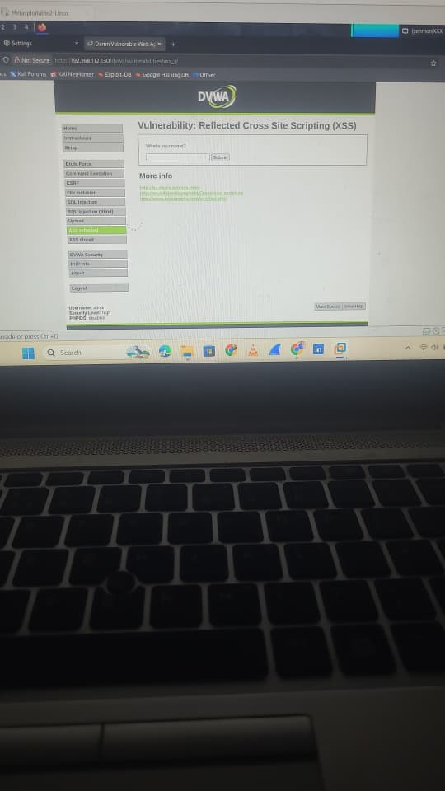
Screenshot 2 – Payload Reflection and Execution
